UML Class Diagram and OOP Principles
APA

Cynthia Turner
Southern New Hampshire University
CS-230: Module One - UML Class Diagram
Professor Alexander Dubinski
May 4th, 2026

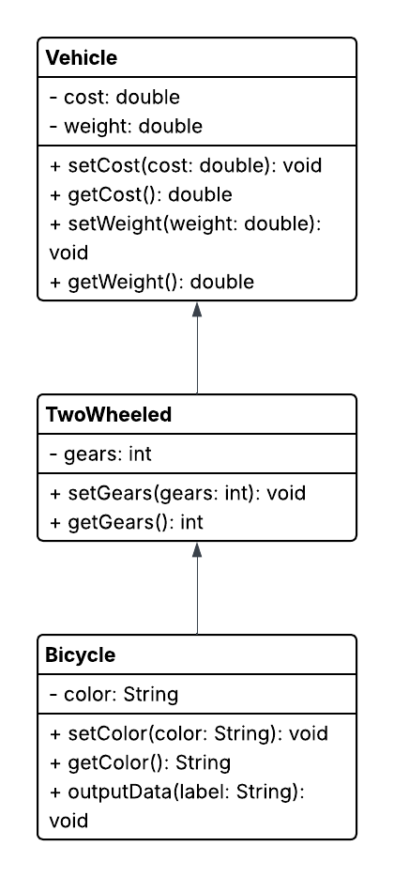
Object-Oriented Programming Principles
The UML class diagram illustrates several key object-oriented programming (OOP) principles, including inheritance, encapsulation, polymorphism, and abstraction.
Inheritance is demonstrated through the hierarchical relationship between the classes. The Bicycle class inherits from the TwoWheeled class, and the TwoWheeled class inherits from the Vehicle class. This means that Bicycle is a type of TwoWheeled, and the TwoWheeled class is a type of Vehicle. This structure allows shared attributes and methods to be reused across multiple classes, reducing redundancy and improving code organization.
Encapsulation is shown by the use of private attributes, such as cost, weight, gears, and color, along with public getter and setter methods. This approach protects the internal data of each class and ensures that it can only be accessed or modified through controlled methods.
Polymorphism is demonstrated using multiple constructors and flexible method usage, allowing objects to behave differently depending on how they are created and used.
Abstraction is represented by the way the classes model real-world objects while hiding unnecessary implementation details. The UML diagram focuses on the essential structure, such as class relationships, attributes, and methods, rather than the underlying code logic.
Overall, the diagram effectively represents how object-oriented principles are used to design and organize the application.

